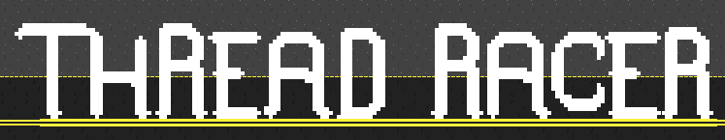
Multithreaded Racing Game Project Report
Team Members: Justin Spires, Bryan Nguyen, Grant Harvey
10/22/2024
Game Design
The game is built around a 51x29 grid of 25 pixel wide square tiles, with four cars.. The grid is filled with 100 obstacle blocks and some power up blocks. The cars can move at random in any direction but backwards at differing speeds. After a car reaches the end, they win and you can race again. The user controls the purple car and the yellow car while the other 2 or 3 cars are controlled by an AI randomly choosing directions randomly to go in.
Threading and Synchronization Implementation
Threading is represented by the four autonomous cars, each given their own thread which handles their collision on the grid, each other, and the goal. Each thread (car) will enter the critical section when attempting to move and will exit the critical section after updating the GUI.
Synchronization is implemented using a custom monitor class called Lock. This class contains two variables locked and condition alongside 2 functions to interact with these variables. The locked variable is a boolean semaphore that is used to handle the synchronization. The condition variable is an instance of the threading.condition class which is used to handle blocking and waking threads.
Threads will call the acquire function when attempting the enter critical section. If there are no other threads in the critical section, locked is false, then the thread will acquire the lock and enter critical condition. If there is another thread in the critical section, locked is true, then the monitor will use the condition to block the thread.
Threads exiting the critical section will call the release function. The release function will unlock the monitor, set locked to false, and wake up any currently blocked threads.

Screenshots (Video attached w/ report)
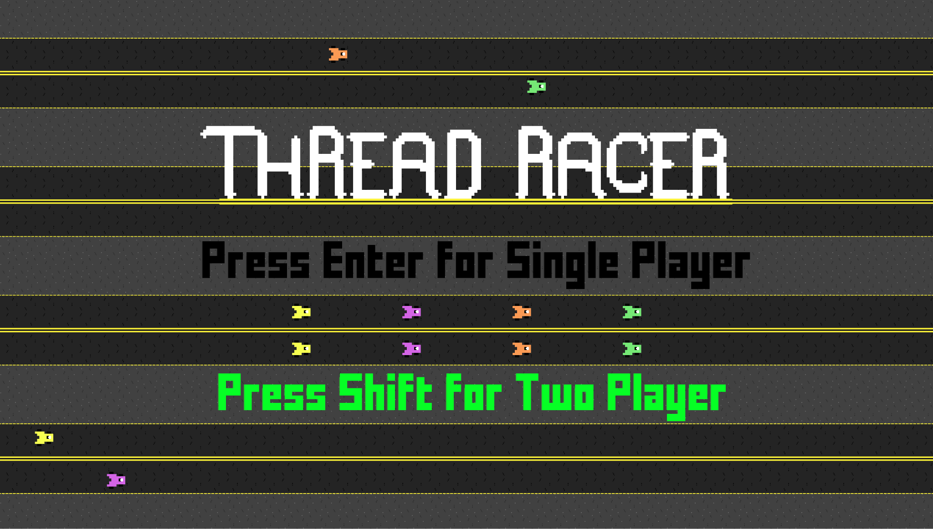
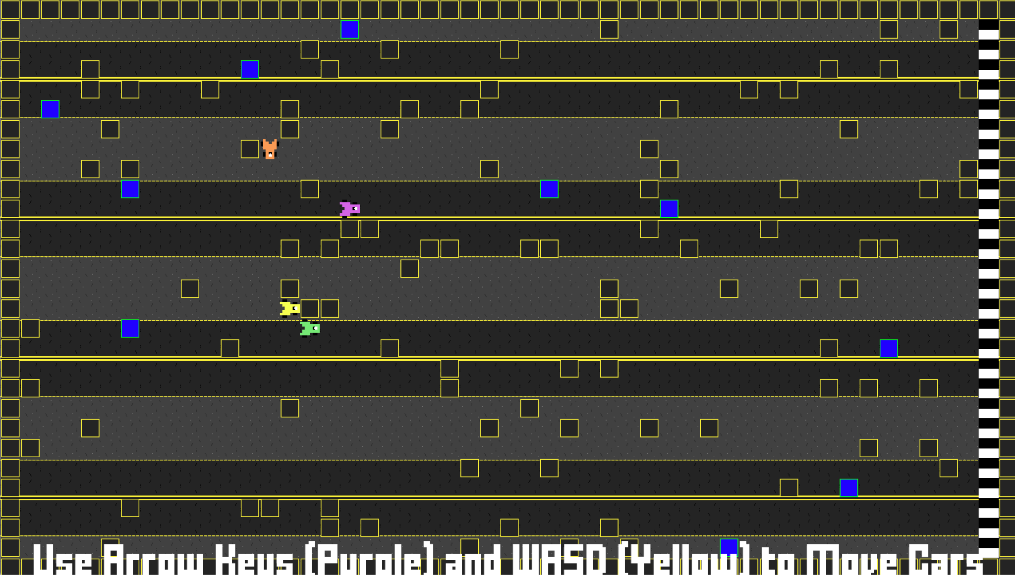
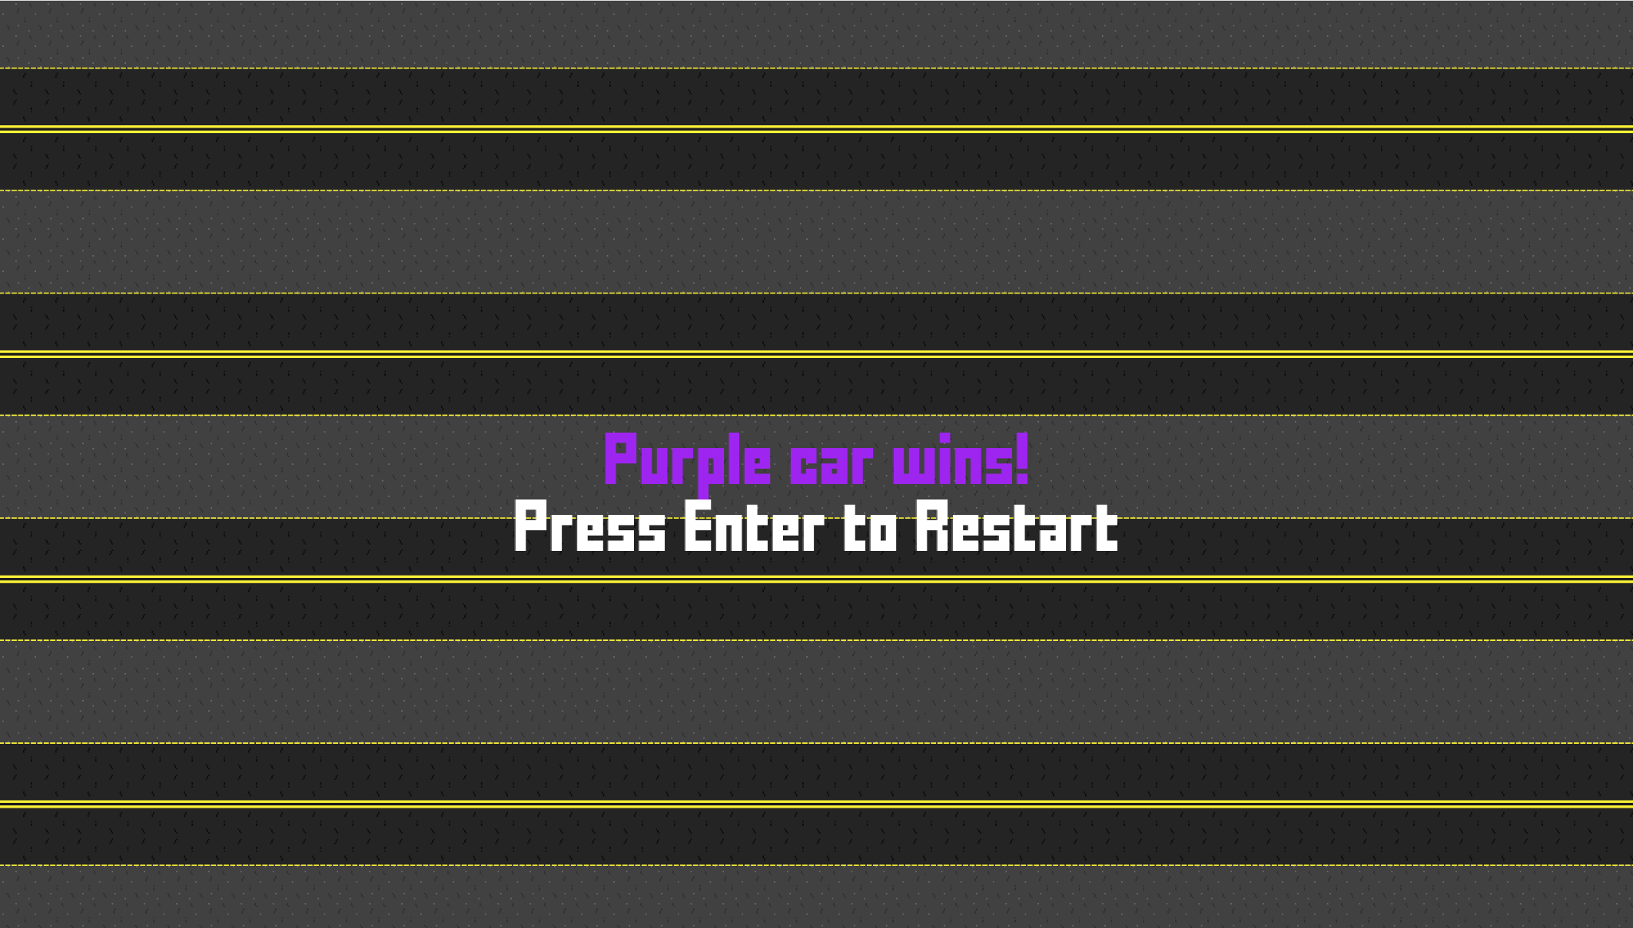
Appendix (game.py)
# Justin Spires' contributions:
# -Set up main project
# -Designed gameplay
# -Bug fixing and implementing others' contributions
#
# Bryan Nguyen's contributions:
# -Added threading, synchronization to cars
#
# Grant Harvey's contributions:
# -Created all art and audio for project
# -Programmed main menu, car movement, art implementation, and sound implementation

import pygame
import random
import time
import threading
import os

pygame.init()
pygame.mixer.init()

# Grid constants
GRID_WIDTH = 51
GRID_HEIGHT = 29
TILE_SIZE = 25
WINDOW_WIDTH = GRID_WIDTH * TILE_SIZE # 1285 pixels wide default
WINDOW_HEIGHT = GRID_HEIGHT * TILE_SIZE # 725 pixels tall default

# Colors
WHITE = (255, 255, 255)
BLACK = (0, 0, 0)

# Get the current directory of the script or .exe
base_path = os.path.dirname(os.path.abspath(__file__))

# Load the custom font (e.g., 'your_font.ttf') and set the font size
font_path = os.path.join(base_path, 'art', 'pixelFont.TTF')
font = pygame.font.Font(font_path, 32)

# Load and play music file
music_path = os.path.join(base_path, 'art', 'race.flac')
pygame.mixer.music.load(music_path)
pygame.mixer.music.play(loops=-1)
power_up_sound_path = os.path.join(base_path, 'art', 'powerUp.flac')
power_up_sound = pygame.mixer.Sound(power_up_sound_path)

# Car Directions
UP = 0
RIGHT = 1
DOWN = 2

# Initialize window
screen = pygame.display.set_mode((WINDOW_WIDTH, WINDOW_HEIGHT))
pygame.display.set_caption("Thread Racer")

# Clock
clock = pygame.time.Clock()

# Game Variables
GAME_ACTIVE = False
GAME_PAUSED = False
WINNER = None
CARS = []
GRID = None
TWO_PLAYER_MODE = False
POWERUP_COUNT = 10
POWERUP_SPEED_INCREASE = 50

# Custom Lock class for managing access to shared resources
class Lock:
def __init__(self):
self.locked = False
self.condition = threading.Condition()

def acquire(self):
with self.condition:
while self.locked:
self.condition.wait() # Wait until the lock is released
self.locked = True # Acquire the lock

def release(self):
with self.condition:
self.locked = False # Release the lock
self.condition.notify_all() # Notify other threads waiting for the lock

# Global lock instance
lock = Lock()

class Car(threading.Thread): # Extend the Car class to be a thread
def __init__(self, image_path, x, y, direction, manual_control=False):
threading.Thread.__init__(self)
self.image = pygame.image.load(image_path)
self.image = pygame.transform.scale(self.image, (TILE_SIZE, TILE_SIZE))
self.x = x
self.y = y
self.start_x = x # Store initial positions for restart
self.start_y = y
self.direction = direction
self.rotated_image = self.image
self.next_move_time = 0
self.running = True
self.manual_control = manual_control # Added flag for manual control (purple car)

# Reset car
def reset(self):
self.x = self.start_x
self.y = self.start_y
self.direction = RIGHT # Face the car to the right before it moves
self.rotated_image = self.image
self.next_move_time = 0

def run(self):
while self.running: # Keep the thread running for the car
current_time = pygame.time.get_ticks() # Get current time in milliseconds
if not self.manual_control: # Only auto-move if it's not manually controlled
self.move(current_time)
time.sleep(0.05) # Control the speed of the thread

def stop(self):
self.running = False

def move(self, current_time):
# Global flags to prevent car threads from moving when they're not supposed to
global WINNER, GAME_ACTIVE
movement = [(0, -1), (1, 0), (0, 1), (-1, 0)] # UP, RIGHT, DOWN, LEFT
if self.manual_control:
# Manual movement does not depend on time intervals
# Direction is set based on key input in the main loop
new_x = self.x + movement[self.direction][0]
new_y = self.y + movement[self.direction][1]
else:
# Automatic movement (AI-controlled cars)
# When the car's ready to move again, pick a direction randomly and set a new burst time
if current_time >= self.next_move_time:
self.direction = random.choice([UP, RIGHT, DOWN])
new_x = self.x + movement[self.direction][0]
new_y = self.y + movement[self.direction][1]

if current_time >= self.next_move_time:
lock.acquire() # Manually acquire the lock for shared resources access
try:
if GAME_ACTIVE and not GAME_PAUSED:
# If the car is not in a wall and not entering a tile a car is already in or entering, move to it
if GRID[new_y][new_x] != 1 and not any(car.x == new_x and car.y == new_y for car in CARS):
self.x = new_x
self.y = new_y

# Powerup handler
if GRID[self.y][self.x] == 3:
power_up_sound.play()
if self.manual_control:
self.next_move_time -= POWERUP_SPEED_INCREASE
else:
self.next_move_time = current_time + random.randint(40,130)
# then, remove the powerup by setting it to 0
GRID[self.y][self.x] = 0
# If the car's on a win tile, set the car as the winner and set the semaphore
if GRID[self.y][self.x] == 2:
WINNER = self.image
GAME_ACTIVE = False
finally:
lock.release() # Always release the lock after accessing shared resources

# Rotate the car based on direction
if self.direction == UP:
self.rotated_image = pygame.transform.rotate(self.image, 90)
elif self.direction == DOWN:
self.rotated_image = pygame.transform.rotate(self.image, -90)
else:
self.rotated_image = self.image # Facing right by default

# Delay the car's movement by a random interval
self.next_move_time = current_time + random.randint(40, 180)
# Delay user controlled car more to make it fair
if self.manual_control:
self.next_move_time = current_time + random.randint(140, 150)
else:
self.next_move_time = current_time + random.randint(50, 60)

def draw(self):
car_rect = pygame.Rect(self.x * TILE_SIZE, self.y * TILE_SIZE, TILE_SIZE, TILE_SIZE)
screen.blit(self.rotated_image, car_rect)

def create_grid():
grid = [[0 for _ in range(GRID_WIDTH)] for _ in range(GRID_HEIGHT)]

for i in range(GRID_WIDTH):
grid[0][i] = 1
grid[GRID_HEIGHT - 1][i] = 1
for i in range(GRID_HEIGHT):
grid[i][0] = 1
grid[i][GRID_WIDTH - 1] = 1

# Add some random walls
for _ in range(100):
rand_x = random.randint(1, GRID_WIDTH - 4)
rand_y = random.randint(1, GRID_HEIGHT - 2)
# Prevent cars from being on the same row as blocks
if rand_x > 2:
rand_x += 1

if grid[rand_y][rand_x] == 0:
grid[rand_y][rand_x] = 1

# Create the goal tiles
for i in range(GRID_HEIGHT - 2):
grid[i + 1][GRID_WIDTH - 2] = 2

# Create the powerup tiles
for _ in range(POWERUP_COUNT):
rand_x = random.randint(1, GRID_WIDTH - 4)
rand_y = random.randint(1, GRID_HEIGHT - 2)
if rand_x > 2:
rand_x += 1

grid[rand_y][rand_x] = 3

return grid

def draw_grid(grid):
# Create the full path to the image files
finish_line_path = os.path.join(base_path, 'art', 'finishLine.png')
wall_path = os.path.join(base_path, 'art', 'wall.png')
power_up_path = os.path.join(base_path, 'art', 'powerUp.png')

finish_line = pygame.image.load(finish_line_path)
wall = pygame.image.load(wall_path)
power_up = pygame.image.load(power_up_path)

for y in range(GRID_HEIGHT):
for x in range(GRID_WIDTH):
tile = grid[y][x]
if tile == 1: # Wall
screen.blit(wall, (x * TILE_SIZE, y * TILE_SIZE))
elif tile == 2: # Goal
screen.blit(finish_line, (x * TILE_SIZE, y * TILE_SIZE))
elif tile == 3: # Powerup
screen.blit(power_up, (x * TILE_SIZE, y * TILE_SIZE))

def draw_text(text, color, y_offset=0):
text_surface = font.render(text, True, color)
text_rect = text_surface.get_rect(center=(WINDOW_WIDTH // 2, WINDOW_HEIGHT // 2 + y_offset))
screen.blit(text_surface, text_rect)

def update_grid():
bkg_path = os.path.join(base_path, 'art', 'background.png')
bkg = pygame.image.load(bkg_path)
screen.blit(bkg, (0, 0))
draw_grid(GRID)
for car in CARS:
car.draw()
pygame.display.flip()

def reset_game():
global GRID, WINNER, GAME_ACTIVE, GAME_PAUSED

WINNER = None
GAME_ACTIVE = False
GAME_PAUSED = False

GRID = create_grid()

for car in CARS:
car.reset()

def start_game():
global GAME_ACTIVE
GAME_ACTIVE = True

def show_pause_menu():
bkg_path = os.path.join(base_path, 'art', 'background.png')
bkg = pygame.image.load(bkg_path)
screen.blit(bkg, (0, 0))
draw_text('Game Paused', WHITE)
draw_text('Press Space to Unpause', WHITE, 50)
draw_text('Press Enter to Restart', WHITE, 100)
pygame.display.flip()

def main():
# Initialize variables, create grid
global GRID, CARS, GAME_PAUSED, GAME_ACTIVE, TWO_PLAYER_MODE
GRID = create_grid()

menu_path = os.path.join(base_path, 'art', 'mainMenu.png')
menuImage = pygame.image.load(menu_path)
screen.blit(menuImage, (0, 0))
pygame.display.flip()

# Select one or two player mode
waiting_for_input = True
while waiting_for_input:
for event in pygame.event.get():
if event.type == pygame.KEYDOWN:
if event.key == pygame.K_RETURN:
waiting_for_input = False
elif event.key == pygame.K_LSHIFT or event.key == pygame.K_RSHIFT:
TWO_PLAYER_MODE = True
waiting_for_input = False

# Sets the car's positions based on grid size
CAR_SPACING = (GRID_HEIGHT) // 5
CARS = [
Car(os.path.join(base_path, 'art', 'orangeCar.png'), 3, 1 * CAR_SPACING, RIGHT),
Car(os.path.join(base_path, 'art', 'purpleCar.png'), 3, 2 * CAR_SPACING, RIGHT, manual_control=True), # Manually controlled purple car
Car(os.path.join(base_path, 'art', 'yellowCar.png'), 3, 3 * CAR_SPACING, RIGHT, manual_control=True if TWO_PLAYER_MODE else False),
Car(os.path.join(base_path, 'art', 'greenCar.png'), 3, 4 * CAR_SPACING, RIGHT)
]

# Start car threads
for car in CARS:
car.start() # Start each car's thread

# Main game loop
running = True
while running:
current_time = pygame.time.get_ticks() # Get current time in milliseconds

# Event handling
for event in pygame.event.get():
if event.type == pygame.QUIT:
running = False
GAME_ACTIVE = False
elif event.type == pygame.KEYDOWN:
if event.key == pygame.K_RETURN:
if not GAME_ACTIVE or GAME_PAUSED or WINNER:
reset_game()
start_game()
if event.key == pygame.K_LSHIFT or event.key == pygame.K_RSHIFT:
if not GAME_ACTIVE:
reset_game()
start_game()
# Toggle pause when the game is active
elif event.key == pygame.K_SPACE and GAME_ACTIVE:
GAME_PAUSED = not GAME_PAUSED

# Manual control for purple car using arrow keys
if event.key == pygame.K_UP:
CARS[1].direction = UP
elif event.key == pygame.K_DOWN:
CARS[1].direction = DOWN
elif event.key == pygame.K_RIGHT:
CARS[1].direction = RIGHT

# Manual control for blue car (player 2) using WASD
if TWO_PLAYER_MODE:
if event.key == pygame.K_w:
CARS[2].direction = UP
elif event.key == pygame.K_s:
CARS[2].direction = DOWN
elif event.key == pygame.K_d:
CARS[2].direction = RIGHT

# Display text when the game is paused
if GAME_PAUSED:
pygame.mixer.music.set_volume(0.5) # Pause the music if the game is paused
show_pause_menu()
else:
pygame.mixer.music.set_volume(1)

# If the game is active, update the grid
if GAME_ACTIVE and not GAME_PAUSED:
# tell user the controls
if not TWO_PLAYER_MODE:
draw_text('Use Arrow Keys to Move Purple Car', WHITE, 345)
else:
draw_text('Use Arrow Keys (Purple) and WASD (Yellow) to Move Cars', WHITE, 345)
pygame.display.flip()
# AI-controlled cars move automatically
for car in CARS:
if not car.manual_control:
car.move(current_time) # Let the other cars move automatically
# The manually-controlled cars move based on user input
CARS[1].move(current_time)
if TWO_PLAYER_MODE:
CARS[2].move(current_time)
update_grid()

# If the WINNER semaphore is 1, show text on which car won
if WINNER:
pygame.mixer.music.set_volume(0.5)
end_path = os.path.join(base_path, 'art', 'background.png')
endScreen = pygame.image.load(end_path)
screen.blit(endScreen, (0, 0))
color_name = 'Orange' if WINNER == CARS[0].image else 'Purple' if WINNER == CARS[1].image else 'Yellow' if WINNER == CARS[2].image else 'Green'
draw_text(f'{color_name} car wins!', color_name.capitalize())
draw_text('Press Enter to Restart', WHITE, 50)
pygame.display.flip()

clock.tick(60)

for car in CARS:
car.stop()
pygame.quit()

if __name__ == "__main__":
main()

